Pronunciation-Based Spelling Dictionary

What is Pronunciation-Based Spelling Dictionary
# Source: AI Source: Provided by: [Data Path: Persons Table -> ID Column: 1, Name_En Column: Motasem Essam] -> From: [Chatgpt (GPT-4-turbo)] on [7/30/2025]
A Pronunciation-Based Spelling Dictionary (also called a phonic spelling dictionary or sound-to-spelling dictionary) is designed to help users find the correct spelling of words based on how they sound. It’s especially useful for those who know how a word is pronounced but not how it's spelled.

✅ Key Features:
# Source: AI Source: Provided by: [Data Path: Persons Table -> ID Column: 1, Name_En Column: Motasem Essam] -> From: [Chatgpt (GPT-4-turbo)] on [7/30/2025]
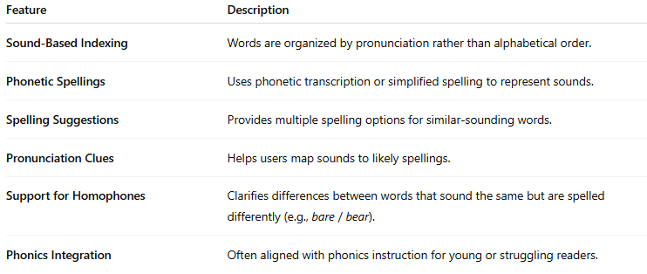
Feature | Description
Sound-Based Indexing | Words are organized by pronunciation rather than alphabetical order.
Phonetic Spellings | Uses phonetic transcription or simplified spelling to represent sounds.
Spelling Suggestions | Provides multiple spelling options for similar-sounding words.
Pronunciation Clues | Helps users map sounds to likely spellings.
Support for Homophones | Clarifies differences between words that sound the same but are spelled differently (e.g., bare / bear).
Phonics Integration | Often aligned with phonics instruction for young or struggling readers.

👤 Target Audience:
# Source: AI Source: Provided by: [Data Path: Persons Table -> ID Column: 1, Name_En Column: Motasem Essam] -> From: [Chatgpt (GPT-4-turbo)] on [7/30/2025]
- Early readers and spellers
- ESL/EFL learners
- Children learning phonics
- Adults with literacy difficulties
- Users with dyslexia or auditory learning preferences

📘 Examples:
# Source: AI Source: Provided by: [Data Path: Persons Table -> ID Column: 1, Name_En Column: Motasem Essam] -> From: [Chatgpt (GPT-4-turbo)] on [7/30/2025]
- The Phonetic Spelling Dictionary
- Oxford Phonics Spelling Dictionary
- Sound-It-Out Spelling Dictionary
- Spelling Dictionary by Sound and Letter Patterns

🟢 Benefits:
# Source: AI Source: Provided by: [Data Path: Persons Table -> ID Column: 1, Name_En Column: Motasem Essam] -> From: [Chatgpt (GPT-4-turbo)] on [7/30/2025]
- Bridges gap between speaking and spelling
- Supports phonics-based learning
- Helps learners self-correct based on sound recognition
- Reduces dependence on alphabetical lookup skills

🔴 Limitations:
# Source: AI Source: Provided by: [Data Path: Persons Table -> ID Column: 1, Name_En Column: Motasem Essam] -> From: [Chatgpt (GPT-4-turbo)] on [7/30/2025]
- Requires some familiarity with phonetic rules or systems
- Less helpful for advanced vocabulary or irregular spellings
- May not include definitions or word usage examples

